作业说明：

1、请大家观看完成第三章8、9节以及第七章1、2、3节内容。

2、请大家仔细观看第三章 第10节《内置对象总结》中我录制的视频《内置对象的应用》、《小小购物车1——注册》，然后完成作业。提交作业时请先将代码复制，然后将执行效果截图；家里没有电脑的同学，请观看视频后进行笔记记录，通过手机图片的形式进行作业提交。

3、学有余力的同学，请将我所讲授的内容都进行敲写一遍的操作。尽快熟悉。

第七周作业：

**【练习】完成购物车的注册和验证页面。**

**运行截图：**

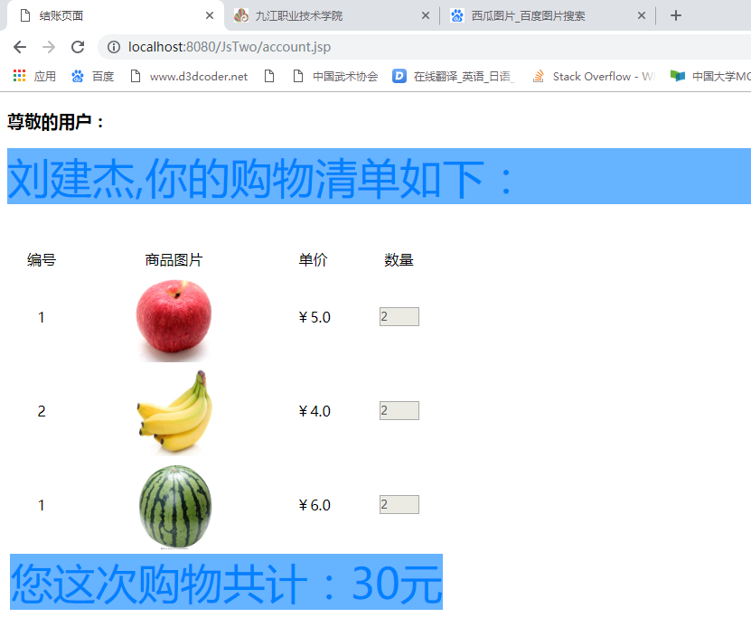

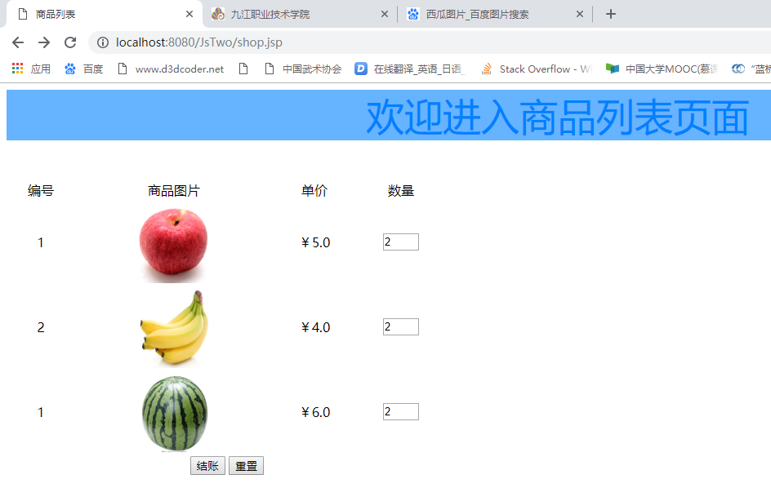

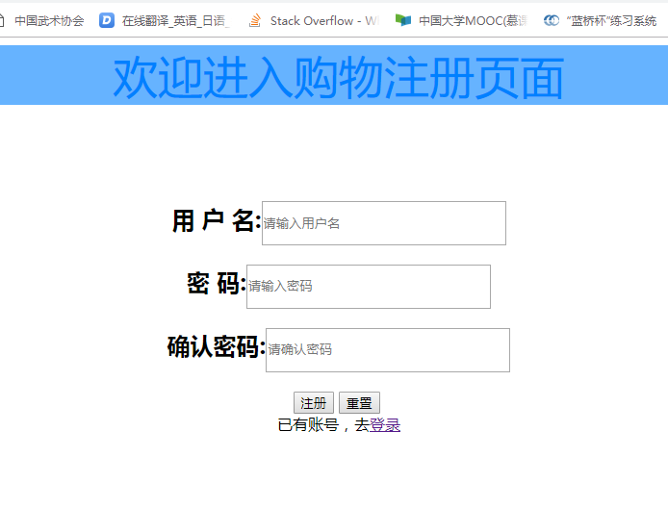

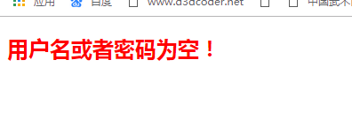

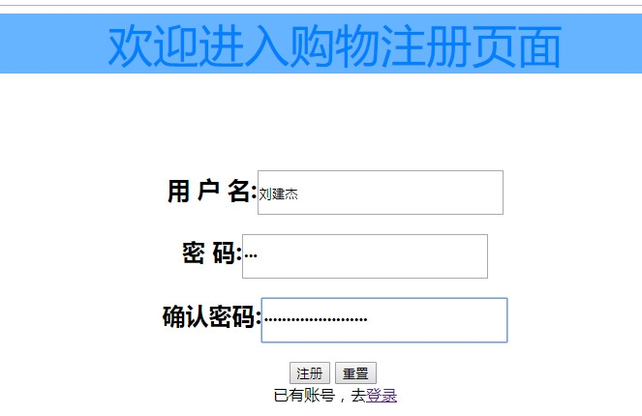

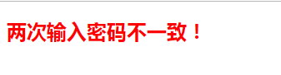

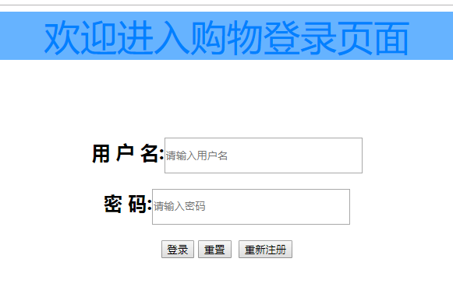

**register.jsp**

<%@ page language=*"java"* contentType=*"text/html; charset=UTF-8"*

pageEncoding=*"UTF-8"*%>

<!DOCTYPE html PUBLIC "-//W3C//DTD HTML 4.01 Transitional//EN" "http://www.w3.org/TR/html4/loose.dtd">

<html>

<head>

<meta http-equiv=*"Content-Type"* content=*"text/html; charset=UTF-8"*>

<title>注册页面</title>

<link href=*"css/degin.css"* rel=*"stylesheet"*>

</head>

<body>

<p>欢迎进入购物注册页面</p>

<div class=*"centerdiv"*>

<form action=*"doreg.jsp"* method=*"post"* class=*"back"*>

<h2>用 户 名:<input type=*"text"* class=*"input"* name=*"user"* placeholder=*"请输入用户名"*/></h2>

<h2>密 码:<input type=*"password"* class=*"input"* name=*"pass"* placeholder=*"请输入密码"*/></h2>

<h2>确认密码:<input type=*"password"* class=*"input"* name=*"passcheck"* placeholder=*"请确认密码"*/></h2>

<input type=*"submit"* value=*"注册"*/>&nbsp;<input type=*"reset"* value=*"重置"*/>

<br/>

已有账号，去<a href=*"login.jsp"*>登录</a>

</form>

</div>

</body>

</html>

**doreg.jsp**

<%@ page language=*"java"* contentType=*"text/html; charset=UTF-8"*

pageEncoding=*"UTF-8"*%>

<!DOCTYPE html PUBLIC "-//W3C//DTD HTML 4.01 Transitional//EN" "http://www.w3.org/TR/html4/loose.dtd">

<html>

<head>

<meta http-equiv=*"Content-Type"* content=*"text/html; charset=UTF-8"*>

<title>验证页面</title>

<link href=*"css/degin.css"* rel=*"stylesheet"*>

</head>

<body>

<%

request.setCharacterEncoding("UTF-8");

String name = request.getParameter("user");

String pwd = request.getParameter("pass");

String pwdcheck = request.getParameter("passcheck");

**if**(!name.isEmpty() && !pwd.isEmpty() && !pwdcheck.isEmpty()){

**if**(pwd.equals(pwdcheck)){

%>

<p><%=name %>欢迎您!</p>

<%

session.setAttribute("name", name);

response.setHeader("refresh","2;URL=shop.jsp");

}**else**{

%>

<h2><font color=*"red"*>两次输入密码不一致！</font></h2>

<%

response.setHeader("refresh","2;URL=register.jsp");

}

}**else**{

%>

<h2><font color=*"red"*>用户名或者密码为空！</font></h2>

<%

response.setHeader("refresh","2;URL=register.jsp");

}

%>

</body>

</html>

**login.jsp**

<%@ page language=*"java"* contentType=*"text/html; charset=UTF-8"*

pageEncoding=*"UTF-8"*%>

<!DOCTYPE html PUBLIC "-//W3C//DTD HTML 4.01 Transitional//EN" "http://www.w3.org/TR/html4/loose.dtd">

<html>

<head>

<meta http-equiv=*"Content-Type"* content=*"text/html; charset=UTF-8"*>

<title>登录页面</title>

<link href=*"css/degin.css"* rel=*"stylesheet"*>

</head>

<body>

<p>欢迎进入购物登录页面</p>

<div class=*"centerdiv"*>

<form action=*"logincheck.jsp"* method=*"post"* class=*"back"*>

<h2>用 户 名:<input type=*"text"* class=*"input"* name=*"user"* placeholder=*"请输入用户名"*/></h2>

<h2>密 码:<input type=*"password"* class=*"input"* name=*"pass"* placeholder=*"请输入密码"*/></h2>

<input type=*"submit"* value=*"登录"*/>&nbsp;<input type=*"reset"* value=*"重置"*/>

&nbsp;<input type=*"button"* onclick="javascript:location.href='register.jsp'" value=*"重新注册"*/>

</form>

</div>

</body>

</html>

**logincheck.jsp**

<%@ page language=*"java"* contentType=*"text/html; charset=UTF-8"*

pageEncoding=*"UTF-8"*%>

<!DOCTYPE html PUBLIC "-//W3C//DTD HTML 4.01 Transitional//EN" "http://www.w3.org/TR/html4/loose.dtd">

<html>

<head>

<meta http-equiv=*"Content-Type"* content=*"text/html; charset=UTF-8"*>

<title>验证页面</title>

<link href=*"css/degin.css"* rel=*"stylesheet"*>

</head>

<body>

<%

request.setCharacterEncoding("UTF-8");

String name = request.getParameter("user");

String pwd = request.getParameter("pass");

**if**(!name.isEmpty() && !pwd.isEmpty()){

**if**(name.equals("刘建杰")&&pwd.equals("123")){

%>

<p><%=name %>欢迎您!</p>

<%

session.setAttribute("name", name);

response.setHeader("refresh","2;URL=shop.jsp");

}**else**{

%>

<h2><font color=*"red"*>用户名或者密码错误！</font></h2>

<%

response.setHeader("refresh","2;URL=login.jsp");

}

}**else**{

%>

<h2><font color=*"red"*>用户名或者密码为空！</font></h2>

<%

response.setHeader("refresh","2;URL=register.jsp");

}

%>

</body>

</html>

**shop.jsp**

<%@ page language=*"java"* contentType=*"text/html; charset=UTF-8"*

pageEncoding=*"UTF-8"*%>

<!DOCTYPE html PUBLIC "-//W3C//DTD HTML 4.01 Transitional//EN" "http://www.w3.org/TR/html4/loose.dtd">

<html>

<head>

<meta http-equiv=*"Content-Type"* content=*"text/html; charset=UTF-8"*>

<title>商品列表</title>

<link href=*"css/degin.css"* rel=*"stylesheet"*>

</head>

<body>

<p>欢迎进入商品列表页面</p>

<form action=*"account.jsp"* method=*"post"*>

<table width=*"40%"*>

<tr align=*"center"*>

<td>编号</td>

<td>商品图片</td>

<td>单价</td>

<td>数量</td>

</tr>

<tr align=*"center"*>

<td>1</td>

<td><img src=*"img/apple.jpg"* width=*"100"* height=*"100"*/></td>

<td>￥5.0</td>

<td><input type=*"text"* name=*"applec"* style="width:*40px*"></td>

</tr>

<tr align=*"center"*>

<td>2</td>

<td><img src=*"img/bana.jpg"* width=*"100"* height=*"100"*/></td>

<td>￥4.0</td>

<td><input type=*"text"* name=*"banac"* style="width:*40px*"></td>

</tr>

<tr align=*"center"*>

<td>1</td>

<td><img src=*"img/water.jpg"* width=*"100"* height=*"100"*/></td>

<td>￥6.0</td>

<td><input type=*"text"* name=*"waterc"* style="width:*40px*"></td>

</tr>

<tr align=*"center"*>

<td colspan=*"4"*><input type=*"submit"* value=*"结账"*/>&nbsp;<input type=*"reset"* value=*"重置"*/></td>

</tr>

</table>

</form>

</body>

</html>

**account.jsp**

<%@ page language=*"java"* contentType=*"text/html; charset=UTF-8"*

pageEncoding=*"UTF-8"*%>

<!DOCTYPE html PUBLIC "-//W3C//DTD HTML 4.01 Transitional//EN" "http://www.w3.org/TR/html4/loose.dtd">

<html>

<head>

<meta http-equiv=*"Content-Type"* content=*"text/html; charset=UTF-8"*>

<title>结账页面</title>

<link href=*"css/degin.css"* rel=*"stylesheet"*>

</head>

<body>

<%

request.setCharacterEncoding("UTF-8");

**int** applec = Integer.valueOf(request.getParameter("applec"));

**int** banac = Integer.valueOf(request.getParameter("banac"));

**int** waterc = Integer.valueOf(request.getParameter("waterc"));

**int** sum = applec * 5 + banac * 4 + waterc * 6;

String name = String.valueOf(session.getAttribute("name"));

%>

<h3>尊敬的用户：</h3>

<p style="text-align:*left*"><%=name %>,你的购物清单如下：</p>

<table>

<tr align=*"center"*>

<td>编号</td>

<td>商品图片</td>

<td>单价</td>

<td>数量</td>

</tr>

<tr align=*"center"*>

<td>1</td>

<td><img src=*"img/apple.jpg"* width=*"100"* height=*"100"*/></td>

<td>￥5.0</td>

<td><input type=*"text"* name=*"applec"* style="width:*40px*" disabled value=*"*<%=applec%>*"*></td>

</tr>

<tr align=*"center"*>

<td>2</td>

<td><img src=*"img/bana.jpg"* width=*"100"* height=*"100"*/></td>

<td>￥4.0</td>

<td><input type=*"text"* name=*"banac"* style="width:*40px*" disabled value=*"*<%=banac%>*"*></td>

</tr>

<tr align=*"center"*>

<td>1</td>

<td><img src=*"img/water.jpg"* width=*"100"* height=*"100"*/></td>

<td>￥6.0</td>

<td><input type=*"text"* name=*"waterc"* style="width:*40px*" disabled value=*"*<%=waterc%>*"*></td>

</tr>

<tr align=*"center"*>

<td colspan=*"4"*><p>您这次购物共计：<%=sum %>元</p></td>

</tr>

</table>

</body>

</html>